**CS691 - Computer Science, Spring 2021**

**Project Initiation Document**

Project: Online Grocery Delivery Application - ‘Carriage’

Project Manager: Vihan Parmar

Start Date: 02-02-2021

Completion Date: 02-06-2021

Table of Contents

Document Purpose **3**

Background to the Proposed Work - Maisha Masnoon **4**

Vision - George Lopez **4**

Project Objectives -Mady Dambele **5**

Project Scope - Lang Gong **6**

Business Case - Roneil Boodram **6**

Assumptions - Jevon Cowell **11**

Constraints - Jevon Cowell **13**

Risk Management Strategy **14**

Deliverables - Tianqi Han **15**

Stakeholders - Vihan Parmar **15**

Project Team- Vihan Parmar **16**

Project Plan **17**

Project Controls - George Lopez **17**

Communication Plan- Lang Gong **18**

*Document Details*

|  |  |  |  |
| --- | --- | --- | --- |
| Version | Modifications | Author | Date |
| 1.0 | Initial PID Document | **Vihan Parmar, Mady Dembele ,George Lopez,Roneil Boodram,Lang Gong,Tianqi Han ,Maisha Masnoon ,Jevon Cowell** | 2/5/2021 |
| 1.5 | PID Document Refinements |  | 2/14/2021 |
|  |  |  |  |
|  |  |  |  |
|  |  |  |  |
|  |  |  |  |
|  |  |  |  |
|  |  |  |  |

*Approvals*

This document requires the following approvals:

|  |  |  |  |  |
| --- | --- | --- | --- | --- |
| Name | Role | Signature | Date | Version |
| Professor Yuri Chernak | **Approver** |  |  | 1.0 |
|  |  |  |  |  |
|  |  |  |  |  |
|  |  |  |  |  |
|  |  |  |  |  |
|  |  |  |  |  |

*Distribution*

This document has been distributed to:

|  |  |  |  |
| --- | --- | --- | --- |
| Name | Role | Date of Issue | Version |
| Vihan Parmar | Project Manager | 2/5/2021 | 1.0 |
| Mady Dembele | Project Owner | 2/5/2021 | 1.0 |
| George Lopez | Lead Developer & DBA | 2/5/2021 | 1.0 |
| Roneil Boodram | Lead Business Analyst | 2/5/2021 | 1.0 |
| Lang Gong | Lead Business Analyst | 2/5/2021 | 1.0 |
| Jevon Cowell | Lead Developer & DBA | 2/5/2021 | 1.0 |
| Tianqi Han | QA Analyst | 2/5/2021 | 1.0 |
| Maisha Masnoon | Tester | 2/5/2021 | 1.0 |

# **Document Purpose**

# **Background to the Proposed Work**

With the fast-paced lives of people today, completing simple tasks as grocery shopping, can now be considered daunting that wastes valuable time. Moreover, the strain on supermarkets due to Covid-19 outbreak gives us a clear indication that there will be a rapid growth in online grocery shopping. By using our online grocery delivery system “Carriage”, people can avoid going to grocery stores in an effort to reduce the interaction with the outside world. This application will enable users to have their groceries picked up for them and delivered to their doorstep. It also allows older adults and persons with disabilities to participate in the shopping experience. Families can save time by ordering grocery items online at their most convenient time. Not only will this save user time, but it will also enable drivers to have a flexible work schedule. In addition, our application will include features such as online payment, recommendation system that will improve user experience, Pre-Filled Digital Card that can be used for NFC Buying Purposes and so on.

With the advent of our proposed application, people can enjoy grocery shopping in the comfort of their house while saving time and money by reducing gas and parking costs.

# **Vision**

The vision of this project is to develop an application, ‘Carriage’ for shopping groceries online and getting them delivered to users at their doorstep. This application will give users the freedom to order groceries from the comfort of their homes while maintaining a safety net during the pandemic. Carriage will help users avoid any social contact in the process and guarantee a seamless delivery. The application utilizes a pool of drivers to work flexibly as delivery drivers in order to fulfill contactless deliveries. The application will have all the tools and features necessary to select, order and review details of the delivery. Carriage will be provided online via (mobile application).

# 

# 

# **Project Objectives**

**Create a user-friendly interface.**

**User Side:**

* Users will have their groceries picked up for them and delivered right to their doorstep.
* Users can set their location to see local participating Grocery and Deli shops (Vendors) and select a vendor and view an assortment of available products that they can order.
* Users can add or remove these items to their cart and checkout once they’re ready.
* On the checkout page, users will be presented with the option to sign up or checkout as guests.
* In the event they choose to checkout as a guest, users must enter their desired address and billing information.
* Registered Users will have this all filled out already.
* Users will be able to use Credit, Debit, or Pre-Filled Digital Card to be used for NFC Buying Purposes like Google Pay, Samsung Pay, and Apple Pay.
* Before confirming their order, users will select a Delivery time.
* Users will be offered exclusive online pricing for Subscribe members and faster delivery times depending on the order for Premium Subscribe members.
* After a successful transaction, users will be presented a confirmation screen with the ability to Track Their Order.
* Users will be able to write a review of their shopping experience.
* Provide order cancellation.

**Driver Side:**

* Driver Application will allow drivers to accept and decline orders and interact with customers to clarify and order statuses.
* Drivers can accept multiple orders for the same store.
* App will also give Drivers an Overview Map of the store to find items.

**Vendor (Grocery Stores, Delis, Super Markets, etc.) Side:**

* Allows Vendors to list, delist, and edit item inventory.
* Vendors can also submit promotions for premium/normal subscribers to use.
* Vendors can use our recommendation system to provide them with accurate and up to minute reports which will allow them to make solid decisions about their products and their directives of campaign.

# 

# **Project Scope**

This project is to develop an online grocery shopping mobile app named Carriage for both Android and iOS users. While providing pickup and delivery services to customers, it can also generate retail sales growth for supermarkets and grocery stores.

The following is a list of our necessary deliverables:

* Users will have their groceries picked up and delivered.
* Users can have flexible login options, they can log in as a guest account, registered account, Google Account Facebook account, or other authorized social accounts.
* Users will be able to choose from a variety of payment options like Credit, Debit, Google Pay, Samsung Pay, Apple Pay so on so forth.
* Users can track delivery status after they place the payment.
* Users have the right to cancel their orders.
* Users will be able to write a review of their shopping experience.
* Carriage will provide users with a platform for complaints and exchange of views on social media.

In order to achieve the scopes above, we will have the following requirements in the technical field:

* Have the required development tools installed prior to the development phase.
* Determine the database to be used.
* Provide user-friendly UI Design.
* Make sure the iOS and Android emulators or physical devices are available before the development phase.

There are also some scopes that are planned for a later project and are intentionally not included in this project:

* (App icon design)
* Licensing and hardware costs.
* Business version(the app for merchant side) of Carriage.

# **Business Case**

**The following is our justification for our project:**

Given the unforeseen circumstances of the COVID-19 pandemic, and the uncertainty as to when pre-pandemic shopping will resume, the demand for a safe and effective means of having groceries delivered to homes is significant. Our application, Carriage, will seek to provide a highly in-demand service with all safety measures in place, while producing a profit due to this demand. Even with the anticipation of a return to a pre-pandemic world in late 2021 or 2022, we are confident that the demand for at-home grocery delivery will still remain (even after the pandemic), as many workers will continue to work from home. In addition, we anticipate many people will prefer the convenience of at-home grocery delivery as an after-effect of the pandemic. By capitalizing on this opportunity, we will be able to create profit, create a valuable service for customers, and create employment for delivery personnel. Our application will utilize a brokerage, subscription, and advertising model. Although we have not created a quantified model RE: revenue and overall timing, we anticipate to gain profit fairly quickly given our brokerage, subscription, and advertising model. By offering advertising opportunities, we can begin to gain revenue from external entities fairly quickly at the launch of this application, followed by revenue from brokerage and subscription fees from end-users and delivery personnel. We feel confident that our application will be implemented during a unique time in history when in-home food delivery services are likely to grow in demand.

|  |  |
| --- | --- |
| **Application Name** | Grocery Delivery “Carriage” |
| **Type of business model** | **Examples:**  **Direct sales, platform, etc. *See the document "Types of Business Models"***  Advertising, Brokerage, and Subscription model |
| **Target audience of external users**  **(Customer Segments)** | **For whom are we creating value?**  Anyone – Families, Stay-at-home moms/dads, Small/big Restaurant, fitness… etc.  **Who are our most important customers?**  Families that are trying to save time by ordering their Groceries online at their most convenient time. |
| **Groups of internal stakeholders, business users** | ***Indicate who will be using the system.***  **Do we need a product development group?**  Yes  **Do we need a sales group?**  Yes  **Do we need a finance group (accounts payable, receivable)?**  Yes  **Do we need a customer support team?**  Yes  **Do we need an advertising management group?**  Yes |
| **Value propositions** | **What value do we deliver to the customer?**  Customers will have their groceries picked up for them and delivered right to their doorstep.  The Application will also have a Pre-Filled Digital Card to be used for NFC Buying Purposes such as Google Pay, Samsung Pay, and Apple Pay.  **Which one of our customer’s problems are we helping to solve?**  This application will reduce our customer interaction with the outside world especially during this COVID19 outbreak.    **What bundles of products and services are we offering to each Customer Segment?**    Based on the customer product viewing and purchases history our application will create a recommender system that will fulfill our customer needs.  Be able to remove or add items from their bundles and make it more affordable for them.  Having a Pre-Filled Digital Card to be used for NFC Buying Purposes such as Google Pay, Samsung Pay, and Apple Pay.  Offering exclusive online pricing for our Subscribe members.  faster delivery times depending on the order for our Premium Subscribe members.  **Which customer needs are we satisfying?**  · Deliver Relevant product recommendations  · Pre-Filled Digital Card for NFC Buying Purposes  · Browse on your time  · Avoid the line and shop in the Comfort of your Home  · Diver/Customer real time interactions to clarify and get order status. |
| **Key resources** | **What Key Resources do our Value Propositions require?**  · Mobile Developers (iOS & Android, if done in React Native then JavaScript Developers)  · Backend Engineers  · Front-End Engineer  · Database Management System (phpMyAdmin)  · Web Service (Like Amazon AWS)  · Domain and Hostname (GoDaddy.com)  · SSL Certificate (GoDaddy.com)  · Machine learning Engineering team  · Software Testing Team  · Business Analyst Team  **Our Distribution Channels?**  · Website  · iOS Mobile Application  · Android Mobile Application    **Customer Relationships?**  · Customer Service  · Social Media (Twitter, Instagram, etc.)  · Self-Service Relationship: customers can add their wanted items to their chart and checkout once they are ready. In addition, customers can communicate with a customer service person to get help during the sales process or after the purchase is complete.  · Long-Term Relationship (loyalty program): To attract customers to pay for the subscriptions, we offer exclusive online price for our members only and a faster delivery times depending on the order of our Premium Subscribers.  **Revenue Streams?**  · Surcharge on orders  · Delivery Fees  · Subscription fees  · Premium Subscription Fees |
| **How the system is used** | **What are the main business use scenarios?**    Mobile Application    User Side:  Within the application users can set their location to see local participating Grocery and Deli shops (Vendors). From there they can select a vendor and view an assortment of available products that they can order. Users can add these items to their cart and checkout once their ready.    On the checkout page, users will be presented with the option to sign up or checkout as guest. The next View will allow the user to enter their desired address and billing information (in the event they choose to checkout as guest. Registered Users will have this all filled out already). Users will be able to use Credit, Debit, Google Pay, Samsung Pay, and Apple Pay as purchasing options.  Before confirming their order, users will select a Delivery time. Premium Tier members will have access to faster delivery times depending on their order. After a successful transaction, users will be presented a confirmation screen with the ability to Track Their Order. |
| **Revenue generation, Revenue streams** | · Selling Ads  · Commission Ads  · Advertising Ads  · Subscription Ads  · Premium Subscription Ads |
| **Key Partners/Suppliers**  **(Stakeholders)** | · Supermarkets  · Local Grocery Stores  · Credit card Vendors  · Customers |
| **Expected Benefits** | · Deliver Relevant product recommendations  · Browse on your time  · Divers/Customers real time interactions to clarify and get order status  · Avoid the line and shop in the Comfort of your Home  · Avoid making multiple trips |
| **Known Prototypes** | Reference some known portals on the Internet that are similar to your business case. You will use these prototypes for developing business, user requirements.  www.instacart.com  [Postmates: Food Delivery, Groceries, Alcohol - Anything from Anywhere • Postmates On-Demand Delivery](http://www.postmates.com/)  [www.doordash.com](http://www.doordash.com) |

# **Assumptions**

|  |  |  |  |
| --- | --- | --- | --- |
| Assumption | Validated by | Status | Comments |
| Project Resources are supplied/acquired for development | DEV/DBA | In-Progress | iOS & Android Test Devices on hand for Local devices to deploy local testing environments. Any other needed material will be given via Course material or though discounted access via student status. Will use React Native |
| Project Resources | QA Analyst | In-Progress | Project Resources will be validated by QA Analyst |
| Regularly Scheduled Meetings | Project Manager | In-Progress | Regular Meetings to check on project progress and address concerns and roadblocks. |
| Same Team | All Members | In-Progress | All members are taking the second section of the course next semester |
| Prep Time for Learning/Re-familiarizing new Technologies | DEV/DBA | In-Progress | Lead developers are mostly familiar with coding languages for our application, but will need time to write code and become familiar with layout of programming needs. |
| Features out-lined in Project Requirements | DEV/DBA | In-Progress | Will provide Weekly Updates through the use of online project management systems like Trello. |
| Use of Github for collaborative version control and development | DEV/DBA | In-Progress | A github will be created, per course requirements, in order to keep track and collaborate effectively on the project. |
| No significant cost will be required throughout the course of the project. | All members | In-Progress | We do not anticipate there will be a large cost to creating our application. Costs will be very minor. |
| Will be using mostly same technology for project | Lead Business Analyst | In-progress | We do not anticipate there will be any major changes in the required technology throughout the building of our application. |
| Will be performing both manual and automated testing | Tester | In-Progress | To prevent application failure and improve efficiency, we will be performing various types of software testing on multiple stages of our application development |
| Requirements will not change | Owner | In Process | Owner is responsible for the  requirements of the project and will  decide main features before the  development |

# 

# **Constraints**

|  |  |
| --- | --- |
| Constraint | Comments |
| Time | The Course is limited by the duration of the semester and it’s participants are limited by their availability. Work from other classes and personal responsibilities will factor into how much time can be dedicated towards the project. Time Zones will also be a factor. |
| Experience | The lack of experience in certain areas and technologies will slow down development and prototyping time. |
| COVID-19 | The virus can cause unforeseen delays and complications, even at this stage of time. |
| API Access | Access to Mapping software may be limited depending on the Operating System. Other tools may require access to Third Party Data that could be rate limited or require payment. |
| Only Two Devs | A project of this undertaking, while not difficult, can lead to issues that may require more than 2 devs in certain periods. This may siphon time away from other team members responsibilities |
| Lead Business Analyst | Although we do not foresee us needing additional technologies for our application, these resources may suddenly be required as we create our application. This may cause us to have to quickly adapt and acquire resources inorder to progress. In addition, we may need finance resources if additional software is needed. |
| Cost of Resources | To conduct software quality assurance testing(SQA) that ensures the quality of our application we need resources and the implementation of these resources often involves immediate cost. |

# **Risk Management Strategy**

|  |  |  |  |
| --- | --- | --- | --- |
| Risk | Probability | Impact | Mitigation Method |
| Vendor approval | Medium | Demand-Supply | Find more vendors to mitigate the loss. |
| File Corruption | Low | Potential loss of whole or part of projects. | Use of Git Version Control and Github. |
| Scheduling and Communication | Medium | Disorganization affecting Development, Business Analysis , and Testing. | Weekly Meeting and Meeting Minutes Summary. |
| Adoption of New Technology | High | Large time sink into learning new technology instead of actual development | Assign needed technology for Product features and schedule time into development to learn and integrate into product. |
| End-User Engagement | High | Non-adoption of application. | Focus on White Box/Black Box testing, Integration testing ,etc |
| Poor Quality Code | Medium | Slower and disorganized Development. Harder and longer Debugging sessions | Use of UML and other design-oriented diagrams for consistency.  Peer Development. |
|  |  |  |  |

Alongside this, there should be a summary of the most significant risks threatening the project.

*Please insert here a Risk Management Process chart from W3 lecture, Slide 46 and explain the process.*

# **Deliverables**

|  |  |  |
| --- | --- | --- |
| Date | Artifact Name | Responsible Party |
| JAN 29 | Project proposal | Project Manager |
| FEB 5 | PID Document | Project Manager |
| FEB 13 | Project Plan, RACI | DBA |
| FEB 20 | Requirement Types | Product owner |
| FEB 27 | Analysis Diagram | Lead Developer |
| MAR 6 | User Requirement | Lead BA |
| MAR 20 | RCT | Lead BA |
| MAR 27 | Functional Requirement | Lead Developer |
| APR 3 | DB model, ER Diagrams | DBA |
| APR 10 | Architecture Diagrams | Lead QA |
| APR 17 | UML Design Diagrams | Product Owner |
| MAY 1 | Test Documentation | Lead QA |
| MAY 8 | Final Presentation | Project Team |

# **Stakeholders**

|  |  |
| --- | --- |
| Stakeholder | Interest |
| End users | Important stakeholders which directly affect the project. The business requirement, business process depends and runs on the basis of purchase patterns determined by the end users. |
| Vendors | Grocery stores, supermarkets will play a key role in delivering desired products. For eg: partnering up with multiple local and retail stores will determine availability of the product, based on which the stream of demand and supply can be maintained. |
| Government | Government agencies should be involved when taxes are incorporated onto various products. |
| Management | Responsible for driving the objective of the project and strategizing an efficient approach towards achieving it. |
| HR Team | Will be responsible for managing resources for the project, technical and non-technical both. |
| Financial Team | Determines the funding for scaling the business and plans a risk management strategy. |

# **Project Team**

|  |  |
| --- | --- |
| Role | Name |
| Project Manager | Vihan Parmar |
| Product Owner | Mady Dembele |
| Lead Business Analyst | Roneil Boodram, Lang Gong |
| Lead Developer, DBA | George Lopez |
| Lead Developer, DBA | Jevon Cowell |
| QA Analyst | Tianqi Han |
| Tester | Maisha Masnoon |

* Roles and Responsibilities of the team roles are defined in the RACI Table below: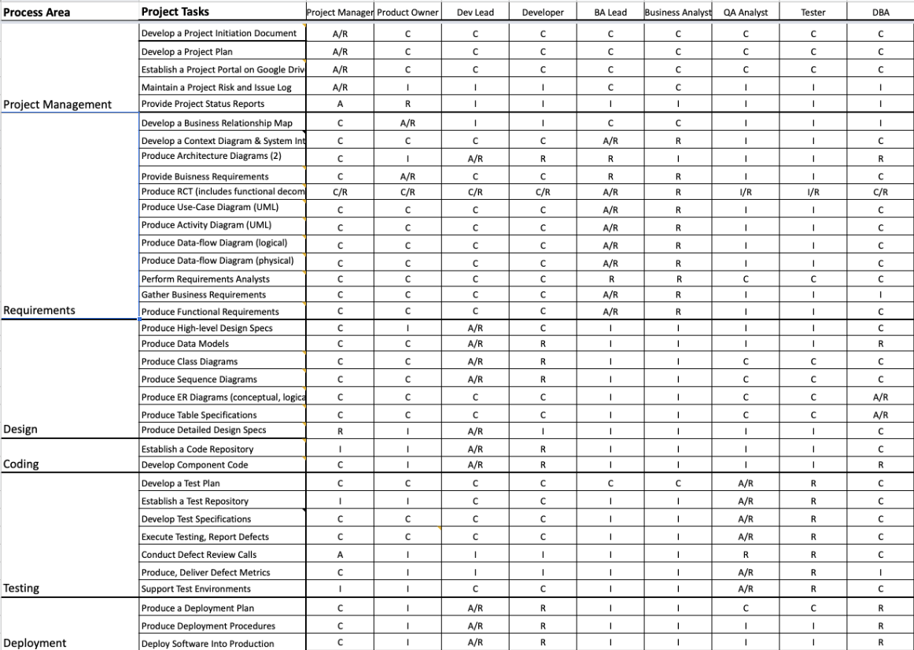

# **Project Plan**

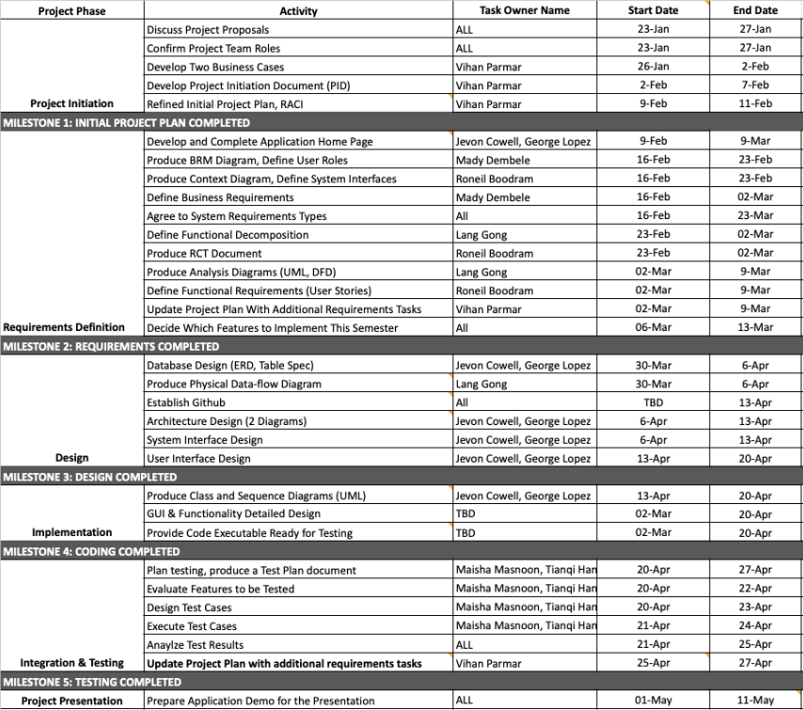

# **Project Controls**

Meetings with the Project Manager will be held regularly to monitor progress and manage arising issues. There will be one Tuesday meeting where the entire group is expected to be present as it aligns with required class times. Project Manager assigns all team members their respective work that has to be completed before each week. Important points and topics will be discussed in the meetings. Final decisions will be made by the end of the meetings taking everyone’s opinion in the consideration.

One or two other meetings will be conducted throughout the week depending on every team member’s availability. These meetings can be remote or in-person. In case any member cannot make it for the meeting, the manager reschedules a meeting or holds it online through pace.zoom.us. Most asynchronous communication will be done on these pace.zoom.us. With follow up communication via WhatsApp.

The Project Manager will produce regular reports for Professor Yuri Chernak. This will include weekly minutes, and projects timeline progress and the related documentations for that week. Project Manager will also keep a track of the deadlines and ensure that everyone plays their role accurately.

Communication will be done via WhatsApp and Slack within the project team section. Email exchange will be the primary means of communicating with Professor Chernak and the stakeholders.

Google Drive will be used as a repository for official documentation and will contain all project documentation. Suggestions for edits requests can be made on slack or via WhatsApp and all documentation is done on Google docs where every team member can work on their assigned segments parallely.

# **Communication Plan**

|  |  |  |  |
| --- | --- | --- | --- |
| **Stakeholder** | **Frequency** | **Type** | **Purpose** |
| **Management** | Daily | WhatsApp, Email, Zoom meeting | To discuss working progress, estimates, requirements prioritization, role and responsibilities within the team. To discuss any issues related to communication between team members or issues related to team members. |
| **Vendors (Grocery stores/ supermarkets)** | Potentially during the testing phase and after release. | Email, online testing sessions, personal meeting | To discuss vendors’ requirements, stock items, and pricing policies. |
| **End Users** | Potentially during the testing phase and after release. | Email, online testing sessions, social media | To obtain feedback for improving overall application. . |
| **Financial Team** | At key stages | WhatsApp, Email, Zoom meeting | To create risk management strategies and action plans; also, to discuss a plan to achieve long term financial goals and accounting. |